Aufgabe 1:

Aufgabe 2: 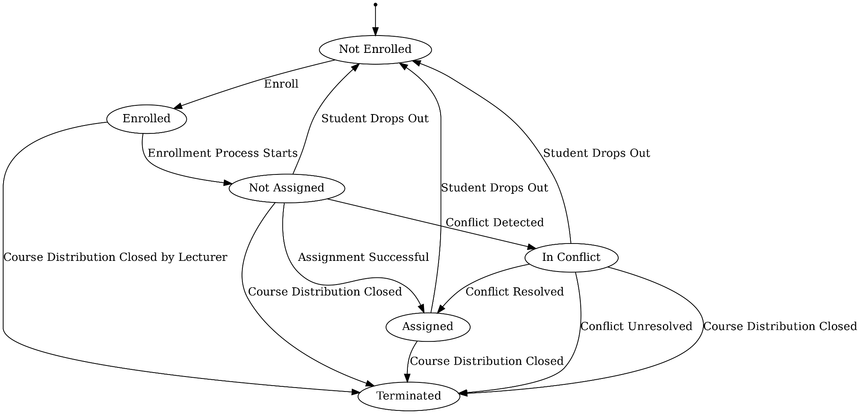
Aufgabe 3:
https://lucid.app/lucidchart/a5d70127-5f1c-435a-9347-fa35299d4343/edit?view_items=mCLoahjwOlFo%2CmCLo9vsMPQCH%2CmCLo5Tw1ZtnB%2CmCLoLozPpPmr%2CmCLoXOXr5Ftu%2CmCLo.GVvAS5A%2CmCLoUxCJEdpR%2CmCLot0FtW5nh%2CmCLoyjV87ePu%2CmCLoC_PCgOQ.%2CmCLol-es7Gu-%2CmCLodZ~eBUvi%2CmCLomOF.Jyh6%2CmCLo9v~YT8c-%2CmCLowEMO1TPj%2CmCLoGbBWtj3J%2CmCLoM75aBeVV%2CmCLosD-gGxCQ%2CmCLoIKEiRrOE%2CmCLoixXSM-ar&invitationId=inv_93fb8480-ab2c-4af2-ad8d-3d7fd5141e48

